Infix to Postfix
Problem Statement: Given an infix expression, Your task is to convert the given infix expression to a postfix expression.
Examples:
Example 1:
Input: a+b*(c^d-e)^(f+g*h)-i
Output: abcd^e-fgh*+^*+i-

Example 2:
Input: (p+q)*(m-n)
Output: pq+mn-*
What is infix expression?
- The traditional method of writing mathematical expressions is called infix expressions.
- It is of the form <operand><operator><operand>.
- As the name suggests, here the operator is fixed inside between the operands. e.g. A+B here the plus operator is placed inside between the two operators, (A*B)/Q.
- Such expressions are easy to understand and evaluate for human beings. However, the computer finds it difficult to parse - Information is needed about operator precedence and associativity rules, and brackets that override these rules.
- Hence we have postfix and prefix notations which make the computer take less effort to solve the problem.
What is postfix expression?
- The postfix expression as the name suggests has the operator placed right after the two operands.
- It is of the form <operand><operand><operator>
- In the infix expressions, it is difficult to keep track of the operator precedence whereas here the postfix expression itself determines the precedence of operators (which is done by the placement of operators)i.e the operator which occurs first operates on the operand.
- E.g. PQ-C/, here – operation is done on P and Q and then / is applied on C and the previous result.
- A postfix expression is a parenthesis-free expression. For evaluation, we evaluate it from left to right.
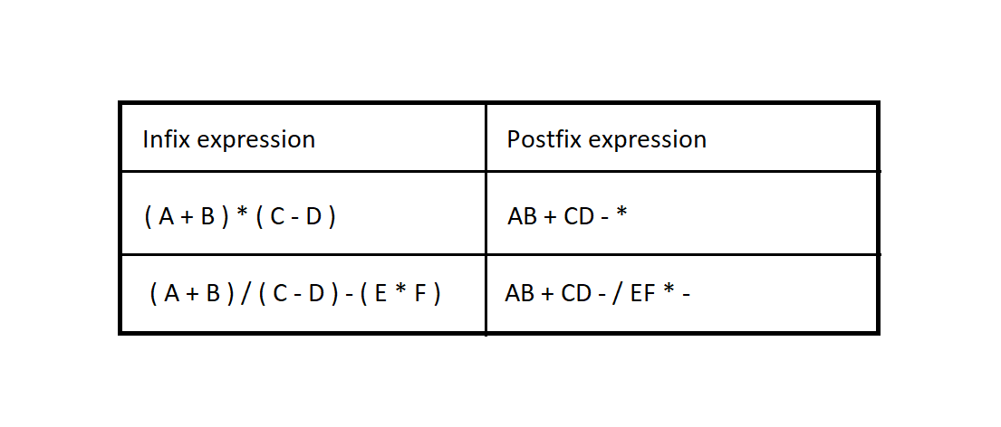
Approach: To convert Infix expression to Postfix
1. Scan the infix expression from left to right.
2. If the scanned character is an operand, Print it.
3. Else,
- If the precedence of the scanned operator is greater than the precedence of the operator in the stack or the stack is empty or the stack contains a ‘(‘, push the character into the stack.
- Else, Pop all the operators from the stack which are greater than or equal to in precedence than that of the scanned operator. After doing that Push the scanned operator to the stack.
4. If the scanned character is an ‘(‘, push it into the stack.
5. If the scanned character is an ‘)’, pop the stack and output it until a ‘(‘ is encountered, and discard both the parenthesis.
6. Repeat steps 2-5 until the entire infix expression is scanned.
7. Print the output.
8. Pop and print the output from the stack until it is not empty.
Code:
import java.util.Stack;

class TUF {
static int Prec(char ch) {
switch (ch) {
case '+':
case '-':
return 1;

case '*':
case '/':
return 2;

case '^':
return 3;
}
return -1;
}
static String infixToPostfix(String exp) {
String result = new String("");
Stack < Character > stack = new Stack < > ();

for (int i = 0; i < exp.length(); ++i) {
char c = exp.charAt(i);

// If the scanned character is an
// operand, add it to output.
if (Character.isLetterOrDigit(c))
result += c;

// If the scanned character is an '(',
// push it to the stack.
else if (c == '(')
stack.push(c);

// If the scanned character is an ')',
// pop and output from the stack
// until an '(' is encountered.
else if (c == ')') {
while (!stack.isEmpty() &&
stack.peek() != '(')
result += stack.pop();

stack.pop();
} else // an operator is encountered
{
while (!stack.isEmpty() && Prec(c) <=
Prec(stack.peek())) {

result += stack.pop();
}
stack.push(c);
}

}

// pop all the operators from the stack
while (!stack.isEmpty()) {
if (stack.peek() == '(')
return "Invalid Expression";
result += stack.pop();
}
return result;
}
}
Output:
Infix expression: (p+q)*(m-n)
Prefix expression: pq+mn-*
Time Complexity: O(N)
Space Complexity: O(N) for using the stack

